**DANANG UNIVERSITY OF SCIENCE AND TECHNOLOGY**

**CENTER OF EXCELLENCE**



**CAPSTONE PROJECT REPORT**

**M-1 REPORT**

**SIMULATE AUTO-FIND TARGET CAR**

Students: Bui Tuan Anh 11ES

Nguyen Hoang Anh Khoa 11ES

Nguyen Truong Trong Nhan 11ES

Tran Ngoc Quang 11ES

Nguyen Tin 11ES

Supervisor: Pham Minh Hai FPT

Dr. Nguyen Hoang Mai DUT

Dr. Truong Thi Bich Thanh DUT

**TABLE OF CONTENT**

**CHAPTER 1: INTRODUCE**

1.1 Project Overview

1.2 Preliminary Solution

1.3 Expected Results

1.4 Proposed Evaluation Method

1.5 Task Assignments

**CHAPTER 1: INTRODUCE**

**1.1 Project Overview**

Khi công nghệ và tự động hóa trở thành một phần quan trọng của cuộc sống con người, hệ thống nhúng đã chứng tỏ sự hữu dụng của nó trong các thiết bị hỗ trợ cuộc sống, như điện thoại, các thiết bị trong nhà, phương tiện di chuyển,... Bằng cách khiến chúng trở nên thông minh hơn, các thiết bị đó dễ dàng sử dụng và đảm bảo an toàn cho con người nhiều hơn.

Trong lĩnh vực ô tô, ngày càng nhiều các thiết bị đang được thay đổi từ hệ thống cơ khí sang hệ thống điện tử. Điều đó đã hối thúc chúng tôi trong việc phát triển một hệ thống điều khiển tự động của ô tô, hệ thống sẽ kiểm soát quá trình di chuyển của ô tô từ 2 điểm bất kỳ. Ngoài ra, ô tô còn có khả năng xử lý vật cản trên đường di chuyển và áp dụng các quy tắc của ô tô khi chạy trên đường.

Trong project này, chúng tôi sẽ thực hiện mô phỏng dựa trên xe mô hình RC có tỉ lệ bằng 1/10 tỉ lệ xe thật.

**1.2 Preliminary Solution**

**Requirements:** Building a self- driving car to avoid obstacles which use SRF- 05 sonar sensor to calculate distance.



Figure 2. Example model of project

**a) Purpose of Project:**

Project purpose is applied for using information technology to” Build a self- driving car which go from A point to B point and is able to avoid obstacles”



Figure 2. PreliminaryDiagrams

**In project:**

* Car (40cm x 18cm).
* Street (2 lines- the width: 60cm).
* The speed of Car (40 km/h).

**In reality:**

* According to Toyota Camry length width height: 4825x 1820x 1480 (mm)
* According to table 3- Technical table decentralized functional motorways of the road and design flow and table 6- Minimum width elements on the cross for plain and hilly terrain.
  + Car will run on a street which is at IV level.
  + The speed of car is about 60 km/h.
  + The width of a line in a street (2 lines): 3.5m.

Both the project and reality, the car run on a street which has a lot of obstacles such as human, other cars, motorbike, bike and across corners.

**b) Subject and The Scope of Research:**

**The subject of the project:**

* Research the theory of SRF- 05 sonar sensor’s distance.
* Motor control method (self- moving method).

**The Scope of Research**

Car’s work area is a surface to be limited by walls, obstacles and is considered as a complete quiet 2-dimension obstacle.

**c) Scientific and Practical Significance of our project**

**Scientific Significance**

Base on scientific knowledge to build a robot that have ability to avoid the object in the street, which use sonar sensor (SRF05).

**Practical Significance**

Potential Application of seft-driving cars is very huge in the future such as seft driving cars for high-way street, seft-parking, seft-finding direction.

**e) Mechanics**

Self-driving car uses SRF- 05 sonar sensors to calculate distance. Robot’s environment is a surface and limited by walls, human and other cars which are considered as complete quite two dimension obstacles. In this project, Robot has 6 SRF-05 sonar sensors, these sensors will be divided into 3 sensors which is located in front of the car and 3 others is located in the back car. In addition, 3 sensors will be located in front of the car, then a sensor will be located in the center of the car and 2 others will be balanced with one. 3 sensors in the back car will be the same with the car’s head. We have to put these sensors like this way because these sensors can detect all obstacles to prevent traffic jams in reality.



**Step 1**

3 SRF- 05 sonar sensors calculate distances through the left, right and straight. Afterthat, these results will be sent to the microcontroller.

The theory of SRF- 05 sonar sensor’s distance:

* SRF05 uses the reflecting principle to calculate distance
* When SRF- 05 wants to calculate distance, it will eject 8 frequencies with 40 KHz, and it will wait for the reflecting waves back. Time from ejecting to reflecting waves is easy for calculating the distance between SRF- 05 and obstacles.
* When ejecting waves and waiting for the reflecting waves backs, SRF- 05’s Echo will keep up to high level (Echo= 1) and SRF-05’s Echo will keep down to low level or after 30us if the reflecting waves come back or there’s no the reflecting waves back.

**Step 2**

Microcontroller based on the calculation of SRF- 05 sonar sensor to process (based on 7 possible conditions when sensor detect obstacles, each condition will have a distinct solution) and decided to process to motor 1 or motor 2.

* Interaction between Amega328P and SRF- 05
* The calculation of SRF- 05 is to calculate time when Echo is at high level.
* To calculate time when Echo is at high level, we use Timer 1 and turn off Amega328’s outside.
* When calculating distance, we activate Trigger 1, a frequency is at least 10 ms then it will wait for Echo which is at high level. Activating timer 1 and waiting for Echo which is low level, when Echo goes down to low level to stop timer and calculate values from timer to draw out distance

## **f) What ‘s task need to do?**

Designing and building self-driving cars has sonar sensor to avoid the obstacles in the street.

**g) Project function**

Self-driving cars have ability to avoid the obstacles by using 6 sonar sensor SRF-05 and 4 color sensor.

**h) Fundamental blocks**

* **Sources block:** supply input power +5V for system.
* **Center controller block:** include 3 small block (Reset block, Initial pulse oscillator block and microcontroller block).
  + Reset block: reset the system to its original state
  + Initial pulse oscillator block: create clock quartz frequency
  + Microcontroller block(Amega328): control the operation of the system, handle the information from the signal of sensor then controls the operation of the engine.
* **Engine controller block (BDESC-Brushed Electronic Speed Controller):** control velocity and reversible dimension of two motor.
* **Sensor block (SRF-05):** identify outside environmental state (obstacles) and then send environmental state to processor-> give responses to control robot to deal with external events.
* **LCD block:** display the results from the sensor (SRF-05)

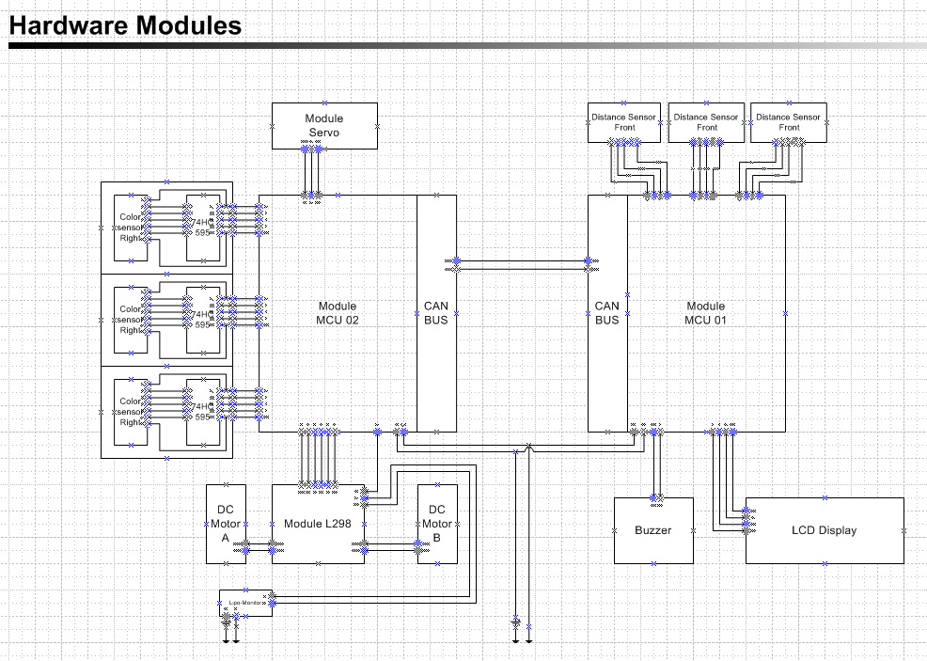

**1.3 Expected Results:**

**Method: Scientific research methods**

Using and Combining some methods such as:

* Pulse Width Modulation Methods (PWM)
* Motor reversal method (H-Bridge Circuit)

**Process:**

Example model



Members ‘s task:

|  |  |  |  |  |
| --- | --- | --- | --- | --- |
| Tuấn Anh | Design and draw schematic | CAN-BUS  OS setup | Speed and steering angles algorithm | Finalization and Optimization |
| Khoa | Ultrasonic Sensor |
| Nhân | PPM signal for Servo and ESC |
| Quang | Settup requirement for project | Speed and steering angles theory | Avoid Obstacles algorithm |
| Tín | Module Encoder |